 | DEPARTMENT OF COMPUTER ENGINEERING
Experiment No. XX
Semester | S.E. Semester III – Computer Engineering
Subject | Skill Based Lab Course: OOP with Java (CSL304)
Subject Professor In-charge | Prof. Swapnil S. Sonawane
Assisting Teachers | Prof. Swapnil S. Sonawane

Student Name | Karthik Subhash
Roll Number | 19102A0045

Title:
Program on Graphics class
Objective:
To develop GUI based application.
Explanation:
The Graphics class of Java AWT is the abstract super class for all graphics contexts which allow an application to draw onto components that can be realized on various devices, or onto off-screen images as well.
A Graphics object encapsulates all state information required for the basic rendering operations that Java supports. State information includes the following properties.
- The Component object on which to draw.
- A translation origin for rendering and clipping coordinates.
- The current clip.
- The current color.
- The current font.
- The current logical pixel operation function.
- The current XOR alternation color
Following is the declaration for java.awt.Graphics class:
public abstract class Graphics extends *Object*

Program Code:
Java Code:
import java.applet.Applet;
import java.awt.*;

public class GraphicsDemo extends Applet{

public void paint(Graphics g){
g.setColor(Color.red);
g.drawString("Graphics Examples:",50, 50);
g.drawLine(20,30,20,300);
g.drawRect(70,100,30,30);
g.fillRect(170,100,30,30);
g.drawOval(70,200,30,30);

g.setColor(Color.pink);
g.fillOval(170,200,30,30);
g.drawArc(90,150,30,30,30,270);
g.fillArc(270,150,30,30,0,180);

}
}

HTML code:
<html>
<body>
<applet code="GraphicsDemo.class" width="300" height="300">
</applet>
</body>
</html>

Output:

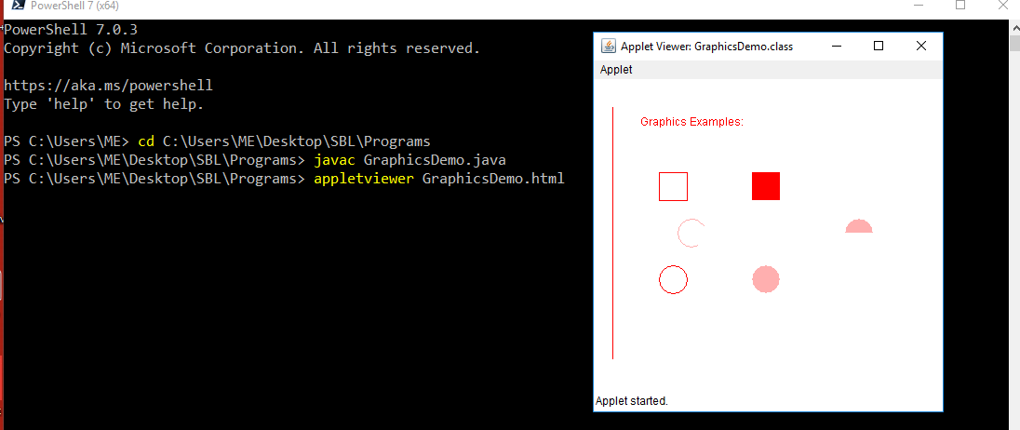

Conclusion:
The graphics toolbox within the Abstract Windowing Toolkit (or AWT) makes it possible for a Java programmer to draw simple geometric shapes, print text, and position images within the borders of a component, such as a frame, panel, or canvas.
The graphics class defines a number of drawing functions, Each shape can be drawn edge-only or filled. To draw shapes on the screen, we may call one of the methods available in the graphics class. The most commonly used drawing methods included in the graphics class are listed below. To draw a shape, we only need to use the appropriate method with the required arguments.

